Question 1:
[org 0x0100]

mov ax, 0xb800
mov es,ax
mov cx,2000
mov di,0
mov ax,0x0720

REP stosw
mov ah,0x1F
mov al,0x41
mov di,160

stosw

mov ax,0x4c00
int 21h
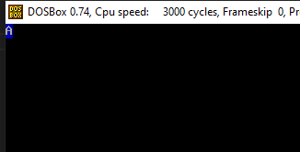
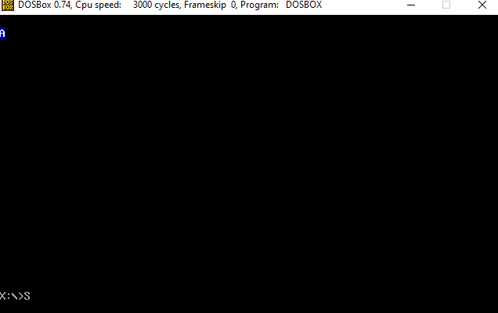

Question 2:
[org 0x0100]
jmp start

string: db 'HELLO'

clrscr:
push es
push ax
push di

mov ax,0xb800
mov es,ax
mov di,0

nextloc:
mov word [es:di],0x0720
add di,2
cmp di,2000
jne nextloc
pop di
pop ax
pop es
ret

printstr:
push bp
mov bp,sp
push ax
push es
push di
push si

mov ax,0xb800
mov es,ax
mov al,80
mul byte [bp+6]
add ax,[bp+8]
shl ax,1
mov di,ax
mov ah,[bp+4]
mov si, string
mov cx,5

print:
lodsb
stosw
loop print

pop si
pop di
pop es
pop ax
pop bp
ret 6

start:
call clrscr

mov ax,2
push ax
mov ax,1

push ax
mov ax,0x17
push ax
call printstr

mov ax,0x4c00
int 21h

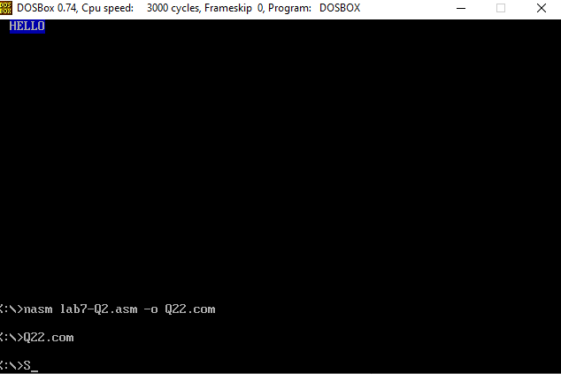

Question 3:
[org 0x0100]

jmp start

char: db 'A'

printstr:
push bp
mov bp,sp
push es
push ax
push di
push si

mov ax,0xb800
mov es,ax
mov di,0
mov ah, [bp+4]
mov cx,2000

print:
mov si,char
lodsb
stosw
loop print

pop si
pop di
pop ax
pop es
pop bp
ret 2

clrscr:
push es
push ax
push di

mov ax,0xb800
mov es,ax
mov di,0

nextloc:
mov word [es:di],0x0720
add di,2
cmp di,2000
jne nextloc
pop di
pop ax
pop es
ret

start:
call clrscr

mov ax, 0x1F
push ax

call printstr
mov ax, 0x4c00
int 21h

